iRevolution: A Data-driven Exploration of Apple’s iPhone Impact in India

1 INTRODUCTION:

1.1 Overview

iRevolution: A Data-driven Exploration of Apple’s iPhone Impact in India. In recent years, India has emerged as a critical market for Apple particularly its iconic iPhone.

This Exploration seeks to unravel the profound influence of the iPhone on the Indian populace, economy, and technology landscape.

Through rigorous data Analysis, we aim to uncover patterns, trend, and insights that illuminate the role of the iPhone in shaping consumer behaviour, industry dynamics, and societal shifts within India.

1.2 Purpose

iPhone Impact in India" likely involves analysing and presenting data to understand the socio-economic, technological, and cultural impact of Apple's iPhone in the Indian context.

This could include assessing consumer behaviour, market dynamics, economic contributions, and potential implications for the society and economy in India.

iPhone Impact in India" is to conduct a comprehensive and analytical investigation into how the introduction and widespread use of Apple's iPhone have influenced various facets of Indian society.

This exploration aims to quantify and qualitatively assess the impact on consumer behavior, technology adoption, economic growth, cultural shifts, education, healthcare, and overall societal advancement.

By utilizing data-driven methodologies, the study seeks to provide insights, trends, and potential

implications for stakeholders, policymakers, and the public in India.

2 PROBLEM DEFINITION & DESIGN THINKING

2.1 EMPATHY MAP:

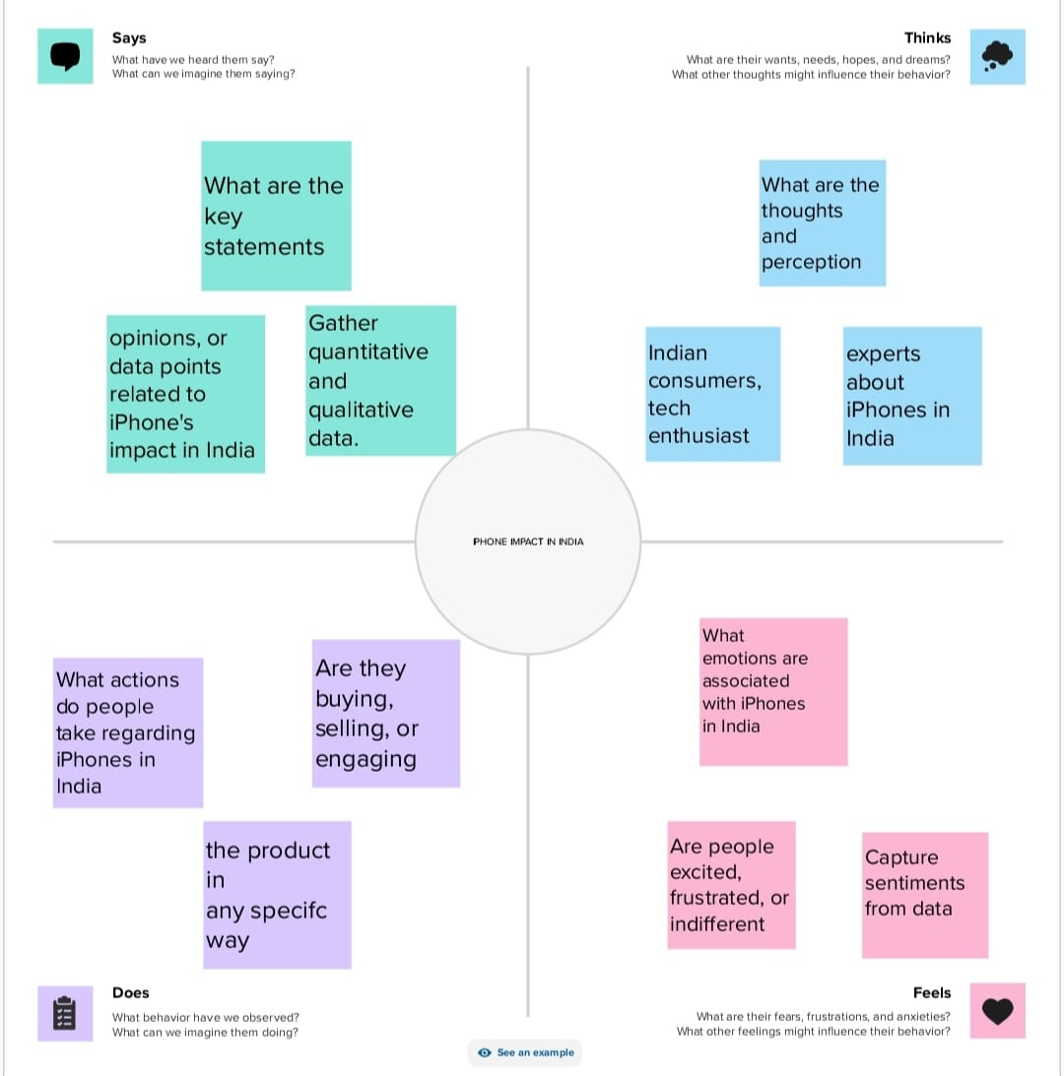

2.2 INDEATION & BRAINSTORMING MAP

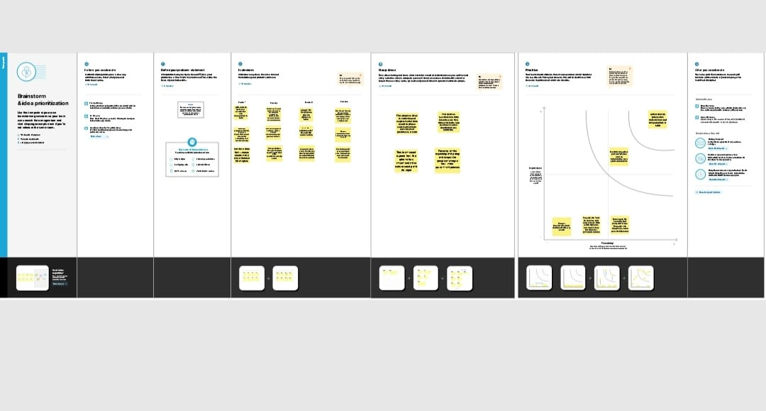

3 RESULT

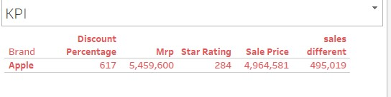

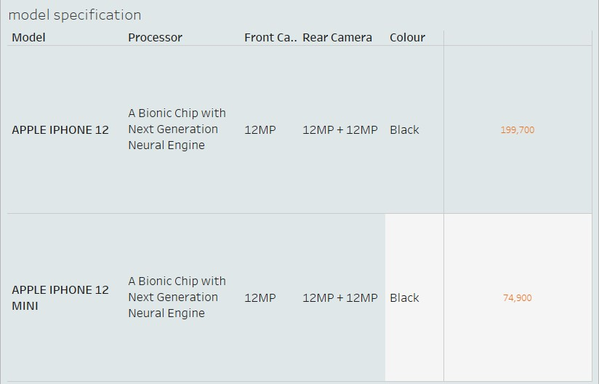

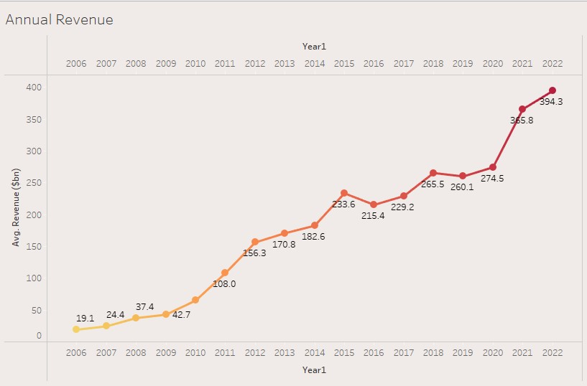

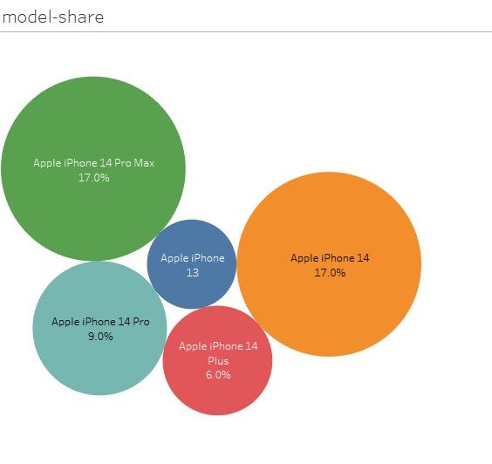

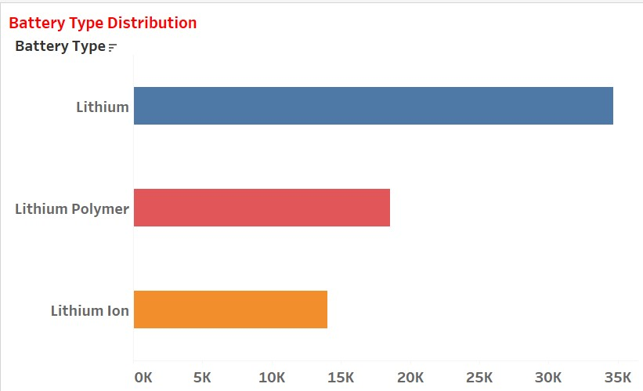

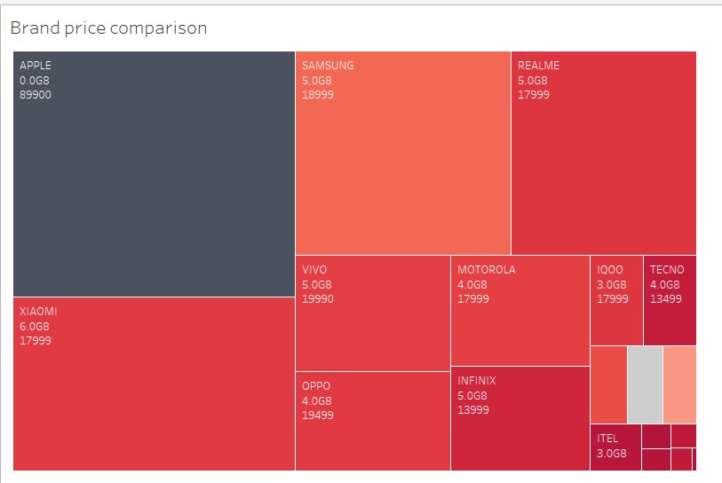

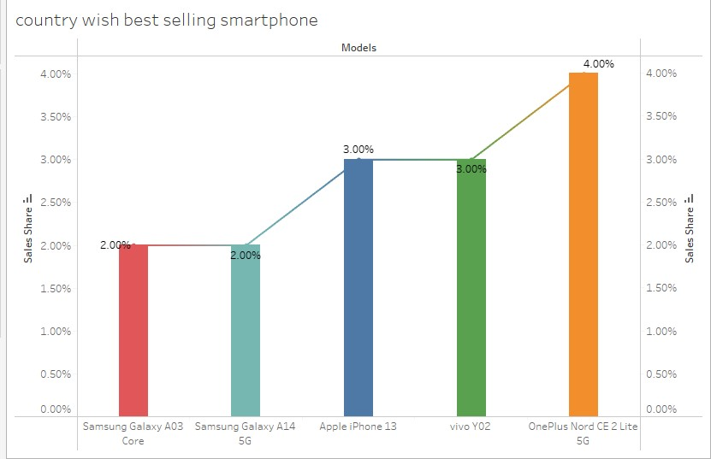

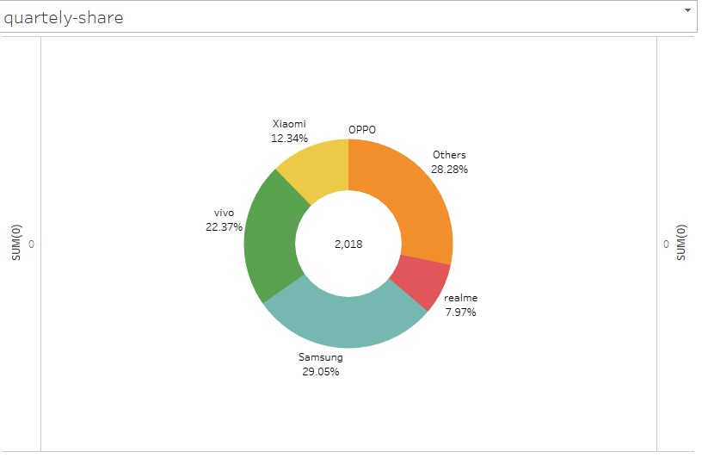

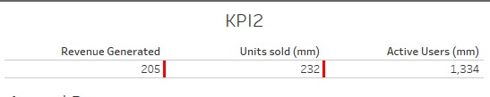

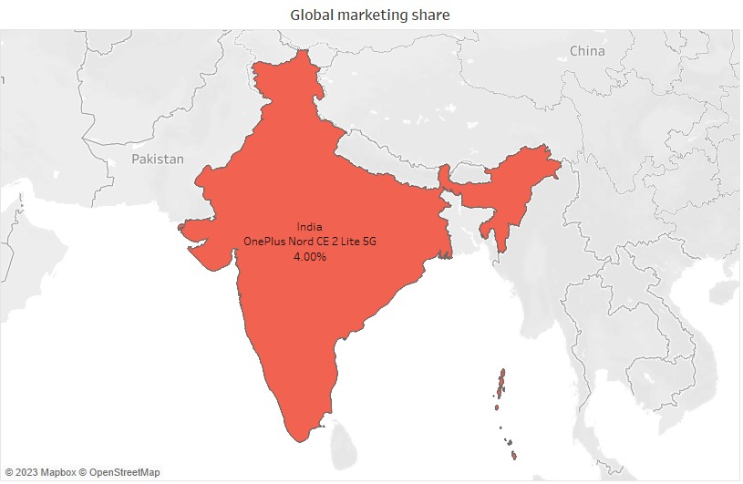

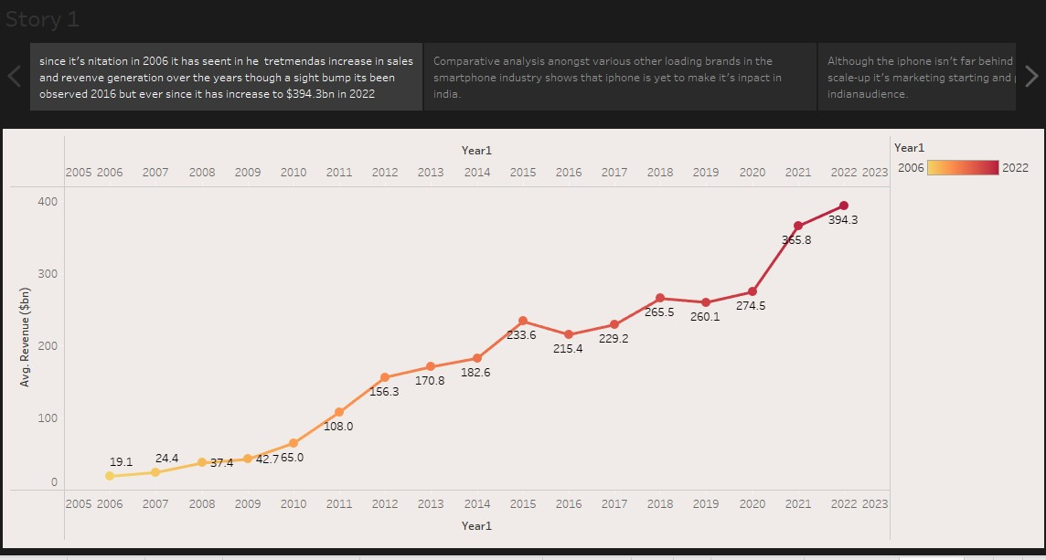

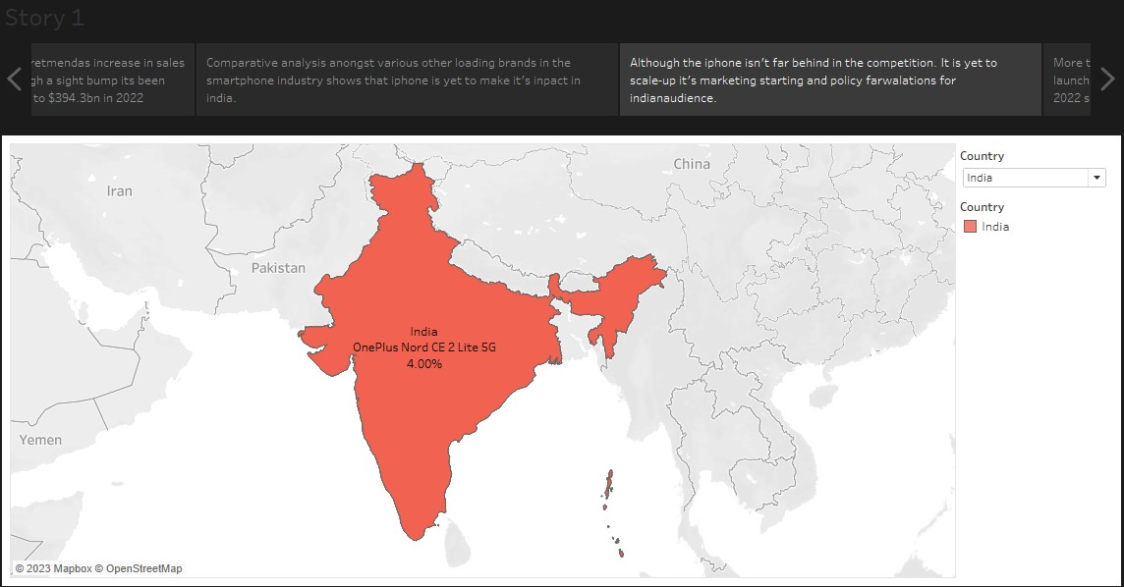

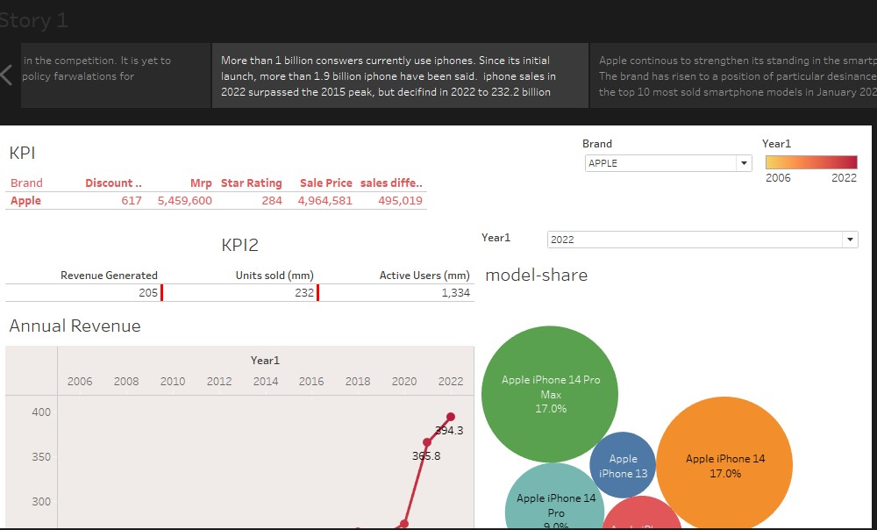

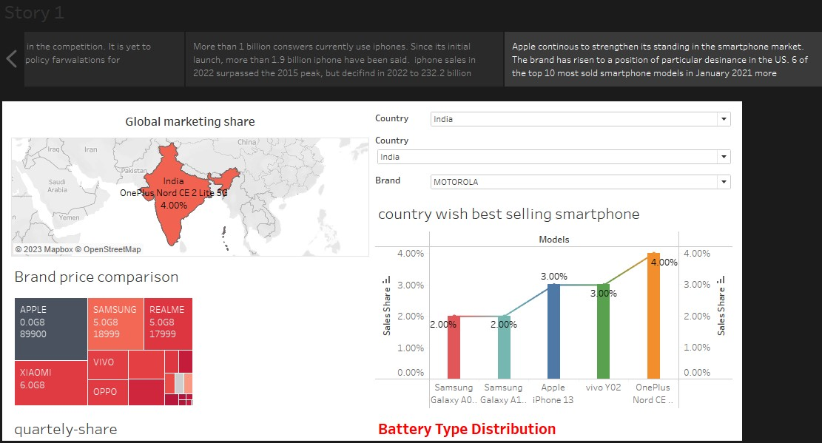

4 ADVENTAGE & DISADVENTAGE

Advantage:

Apple's presence in India has contributed to economic growth by creating job opportunities and fostering investment in the tech sector.

The iPhone has introduced advanced technology to the Indian market, raising the standards of smartphones and encouraging innovation in the local tech industry.

Disadvantage: High Cost and Affordability: iPhones are relatively expensive, making them less accessible to a significant portion of the Indian population, limiting market penetration.

Ecosystem Lock-in: The Apple ecosystem can limit choice and interoperability with non-Apple devices, making it challenging for users to switch to other platforms.

5.APPLICATION:

Brief introduction to the purpose and objectives of the application.

Overview of Apple's iPhone impact in the Indian market.

Data-driven analysis of Apple's contribution to the Indian economy.

Visualizations showcasing economic growth, job creation, and investment.

Graphs and charts illustrating iPhone market share trends over the years.

Regional distribution of iPhone sales and market penetration.

6.CONCLUSION:

Apple's presence in India has spurred economic growth, stimulated job creation and encouraging investment in the tech sector.

The iPhone has propelled technological advancement, setting higher standards for smartphones and fostering innovation in the local tech industry.

Apple's brand value and perception have risen, positioning it as a premium and aspirational brand, appealing to a growing segment of Indian consumers.

The sale of iPhones has bolstered the retail and e-commerce sectors, driving growth and providing a market for Apple products.

7 FUTURE SCOPE:

Integrate APIs or data feeds to provide real-time updates on iPhone sales, market share, economic impact, and technological advancement.

Incorporate machine learning algorithms to predict future trends in iPhone adoption, consumer preferences, and market behavior based on historical data patterns.

Integrate APIs or data feeds to provide real-time updates on iPhone sales, market share, economic impact, and technological advancemt.

Incorporate machine learning algorithms to predict future trends in iPhone adoption, consumer preferences, and market behavior bassed on historical data patterns.